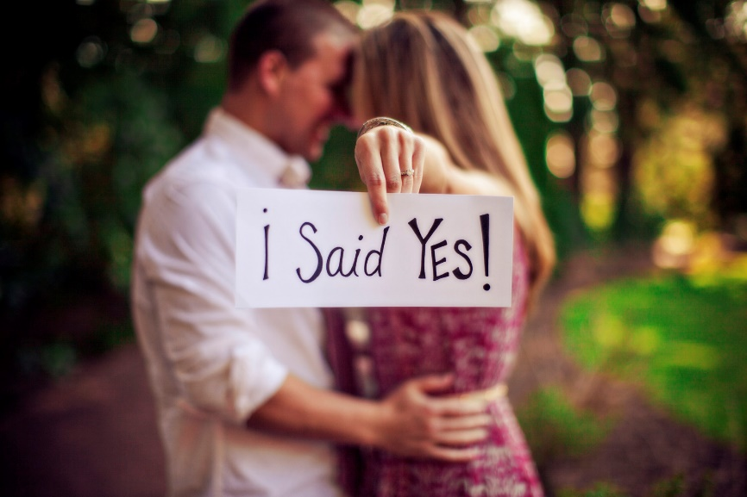

Press Here to Start

Create the Ultimate proposal

Easy Stress-Free Planning

A wonderful way to start your wedding fairytale.

During our personal consultation, our fairy god mothers sprinkle fairy dust onto your ideas ands help you to make that magical moment a proposal for the history books.
From the classical romantic to the courageously adventurous, let our experts make your dream proposal go off without a hitch!

What is needed from you
The Ring
The Partner
The Intent

